Brandon Dooley

Dooleyb1@tcd.ie

Date of Experiment: 9/12/2016

Lab Session: 14:00-16:00

*All circuit diagrams created using CircutDiagram*

*© 2016 Circuit Diagram*

Brandon Dooley ( #16327446 )

CS1025 Laboratory Experiment 4

CS1025 Laboratory Experiment 4

# Objective

* To create a high-pass filter using a capacitor and a resistor.
* To create a low-pass filter using a capacitor and a resistor.
* To investigate the effects different frequencies have on these filters and the respective voltages.

# Method (Part One)

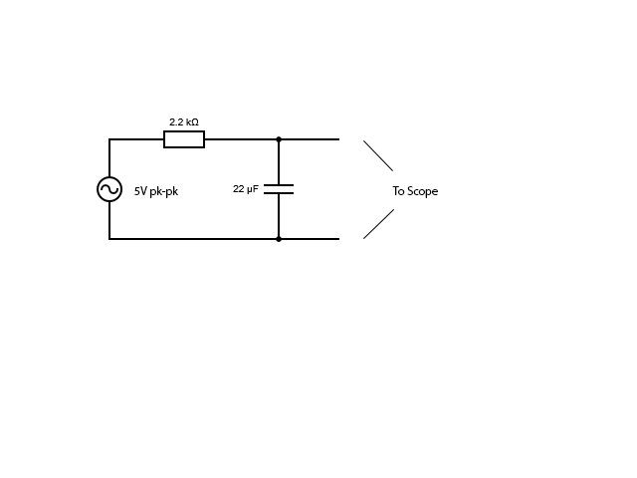 ***Fig 1.1***

1. The apparatus was set up as shown in *Fig 1.1*, with a 2.2kΩ resistor connected in series with a 22µF capacitor. The circuit was then connected to a 5V pk-pk a.c power supply and also to an oscilloscope as shown. The oscilloscopes were calibrated and a superimposed plot of the input and output voltages shown on screen. The frequency was set to 100Hz and the corresponding ratio between the input voltage (Vin) and the output voltages was recorded. The frequency was then increased in intervals off 100Hz up to 20kHz and the respective voltages ratios recorded at each frequency interval. The results were then graphed with peak output voltage against frequency.

# Results (Part One)

# Analysis (Part One)

* At 100Hz the output voltage can be seen to be nearly the exact same as the input voltage (5v pk-pk). There is virtually no difference between the input and output ratio at this stage.
* As the frequency increases the difference (ratio) between the input and output voltages greatly decreases. The voltage falls sharply in the region between 500-5kHz.
* As the graph approaches the 20kHz mark the voltages begin to level off at approx. 0.2V. Judging from the oscilloscope readings these voltages can also be approximated to being nearly d.c.

# Uncertainty & Error (Part One)

* Errors when calibrating a zero reference for the oscilloscope
* Errors when choosing voltages and frequencies on the function generator
* Power lost through other energy conversions e.g heat
* Internal resistance of devices e.g the oscilloscope impacting readings
* Human errors when taking voltage readings off the oscilloscope

# Conclusions(Part One)

* Taking into account the uncertainties and errors above it can be concluded that when a capacitor and resistor are set up as shown above in the *Fig 1.1* they act as in a somewhat filter manner. The system only allows low voltage frequencies to pass through smoothly. As the frequency is increased the voltage is blocked and prevented from being outputted at its full potential.
* With low frequencies, the capacitor has time to charge up to the peak voltage before discharging the this charge on the opposite end of the oscillation cycle. So the output amplitude is somewhat similar to the input amplitude. At low frequencies the reactance of the capacitor will be very large compared to the resistive value of the resistor, and thus the voltage drop across the capacitor will be larger than that across the resistor.
* However, with high frequencies the capacitor is prevented from charging up to the peak voltage and as a result the output amplitude of the system is much less than that of the input. Similarly, at high frequencies the reactance of the capacitor will be much less than that of the resistor and as a result the majority of the voltage will be dropped across the resistor.

# Method (Part Two)

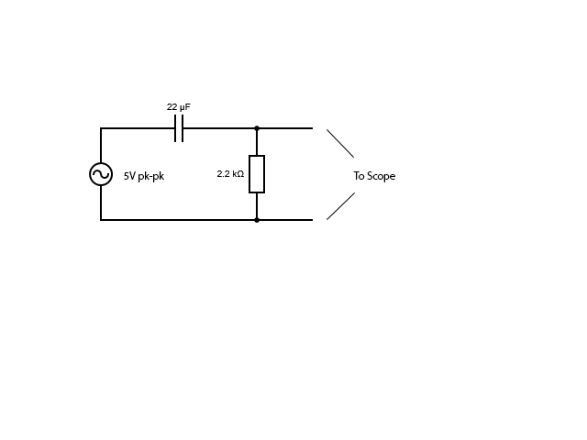 ***Fig 2.1***

1. The circuit was then changed the 22µF capacitor was swapped with the 2.2kΩ resistor. The circuit was then connected to a 5V pk-pk a.c power supply and also to an oscilloscope. The oscilloscopes were calibrated and a superimposed plot of the input and output voltages shown on screen. The frequency was set to 100Hz and the corresponding ratio between the input voltage (Vin) and the output voltages was recorded. The frequency was then increased in intervals off 100Hz up to 20kHz and the respective voltages ratios recorded at each frequency interval. The results were then graphed with peak output voltage against frequency.

# Results (Part Two)

# Analysis (Part Two)

* This time the circuit behaves in the exact opposite manner to the previous circuit in part 1. This time At 100Hz the peak output voltage is extremely low (approx. 0.2V)
* As the frequency becomes larger the difference between the input and output voltages greatly increases.
* As the graph approaches the 20kHz mark the peak output voltage begins to approximate towards the original peak input voltage amplitude of 2.5V.

# Uncertainty and Error (Part Two)

* Errors when calibrating a zero reference for the oscilloscope
* Errors when choosing voltages and frequencies on the function generator
* Power lost through other energy conversions e.g heat
* Internal resistance of devices e.g the oscilloscope impacting readings
* Human errors when taking voltage readings off the oscilloscope

# Conclusions(Part Two)

* Taking into account the uncertainties and errors above it can be concluded that when the capacitor and resistor are interchanged the operation of the filter is too changed. The filter now acts in the opposite manner filtering out low frequency voltages and only allowing voltages with a high frequency to pass through unchanged.
* The capacitor is a reactive device, and thus offers a very high resistance to low-frequency or d.c sources. As it offers a high resistance to low-frequency sources it blocks them from entering through. This can be seen in the graph above. So this type of filter only allows high frequency sources to pass through and not d.c.

# Uses of High and Low-Pass Filters

* A high-pass filterused in conjunction with a low-pass filter to **separate audio** travelling through a **sound system** to send high frequency sound waves to the *tweeter* and then the low frequency waves to the *woofer*. *(Source : Wikipedia)*
* High and low-pass filters are used in **image processing** to perform modifications, enhancements and noise reduction. *(Source : Wikipedia)*
* High-pass filters are used in speakers to reduce the low level noise, eliminate rumble distortions and **amplify higher frequency signals**. *(Source : Electronics Hub)*